**Syllabus**

**Math 20/30-3**

**Miss Gibbon**

**Classroom Expectations**

**Be Open-minded** *~ If you see the worst in any situation or idea without first considering its merits, you only impede your own growth.*

**Be positive** ~ *Attitude is everything. Salt, like math, may not be so good on its own, but it can definitely make everything else that little bit more flavourful.*

**Be respectful** ~ *Others have the right to a quality education, same as you. Don't mess with that.*

**WORK IS EXPECTED TO BE NEAT.** (Use pencil and eraser or buy erasable pens)

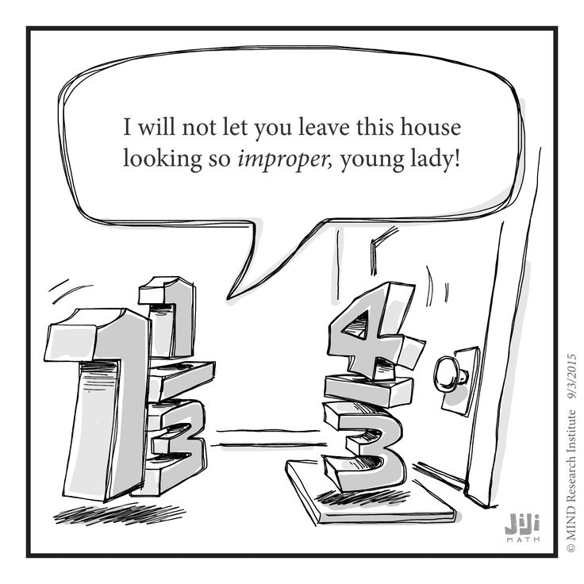

**Materials Required**

Binder

loose-leaf

graphing paper

Pencils and Erasers

Pens/Highlighters

**CALCULATOR**

**Lockdown/Fire drill Discussion**

**Classroom Routines**

**Late** – Sign in when you arrive. Send me a Remind with the reason for your late or you will remain absent.

Format: Late – A bear was standing on my keys. (3:05)

**Bathroom/Drink** – Sign out and sign in to the binder by the door. I need to know where you are AT ALL TIMES. Only one student may be out of the room at a time. When you leave you will close the binder so that others know someone is already out. Open it when you get back.

**Hand in** – There is a bin with your class name on it. **All** work is handed in here unless told otherwise.

**Can and Can’t Do’s**

**Technology** – Will only be used in my classroom at designated times. Parked at all other times in basket on my desk. This is a school wide policy.

“But Miss Gibbon, what happens if I refuse/forget?”

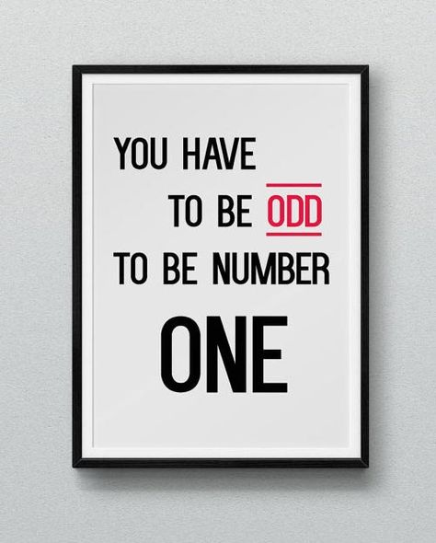**Food and Drink –** You may eat and drink **healthy, quiet food** in my class.

Should you choose to bring a Slurpee to class, you bring me one as well, or I toss yours. Not healthy. (This includes Iced coffee or Iced Cappuccino)

NO: Chips, Cookies, Carbonated beverages…

*If I find food on the floor after your class, food privileges will be lost for the entire class.

**Contact Information:**

**Teacher:** Miss Paige Gibbon

**e-mail:** paige.gibbon@pallisersd.ab.ca

**Remind:** @mathe203 or @mathe303

**Google Classroom:** code:

Will be used to post assignments, keys, and digital lessons

**Grading Scheme**

Class Work 20% *Show me you can expand on what you learn*

Projects 20% *Show me you can apply and expand on what you learn*

Tests 30% *Show that you can combine and remember processes*

(Final Exam 30% *Show you can remember what you have learned)*

If you pass ALL of your tests leading up to the end of the course, the final exam will be exempt.

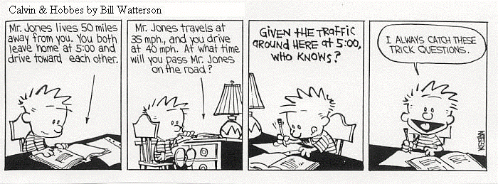

20-3 Tests will be scheduled into class time. If you require a rewrite you must write when you will rewrite on the board. You will give at least 3 days notice of your rewrite and you may or may not have the accommodations you would be given during regular class time. I hope that you will use spares for rewrites to avoid missing class time.

30-3 Tests can be scheduled as needed during class time. The board provides you with your upcoming completion goals.

**Course Rationale**

“Mathematics is a broad-ranging field of study in which the properties and interactions of idealized objects are examined. Whereas mathematics began merely as a calculational tool for computation and tabulation of quantities, it has blossomed into an extremely rich and diverse set of tools, terminologies, and approaches which range from the purely abstract to the utilitarian.” (Wolfram MathWorld)

You have the skills needed to take accurate measurements in Metric and Imperial. You can use trigonometry to solve for angles and side lengths on triangles. You have learned to calculate your income and your taxes. You have the skills necessary to be successful in many trades and diplomas.

Now we will practice these skills and see how their applications may vary while broadening our understanding of the effect of math on our day to day lives. We will model 3D objects, use trigonometry to solve three dimensional problems, include error in our measurements, see how proportional reasoning can be applied to slopes, learn to budget our earnings, and calculate interest on our investments. The concepts above are a small portion of the concepts that will be covered within 20-3 and 30-3, but they demonstrate the importance of these studies. These are the courses that prove not only your capability with the skills learned in grade 10, but your ability to extend that understanding.