**Syllabus**

**Math 10 Common**

**Miss Gibbon**

**Classroom Expectations**

**Be Open-minded** *~ If you see the worst in any situation or idea without first considering its merits, you only impede your own growth.*

**Be positive** ~ *Attitude is everything. Salt, like math, may not be so good on its own, but it can definitely make everything else that little bit more flavourful.*

**Be respectful** ~ *Others have the right to a quality education, same as you. Don't mess with that.*

**WORK IS EXPECTED TO BE NEAT.** (Use pencil and eraser or buy erasable pens)

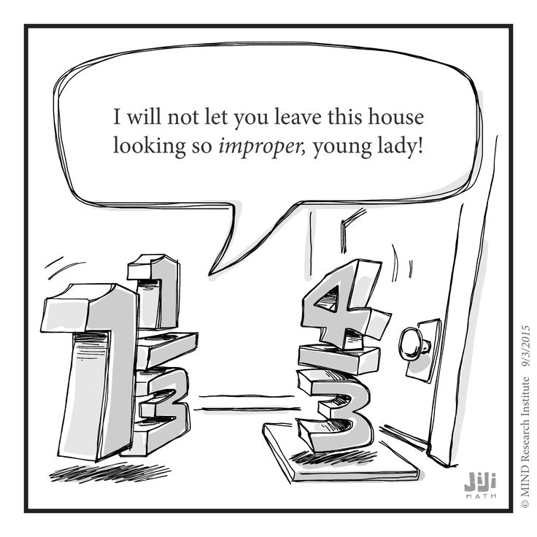

**Materials Required**

Binder

loose-leaf

graphing paper

Pencils and Erasers

Pens/Highlighters

**GRAPHING CALCULATOR**

**Lockdown/Fire drill Discussion**

**Classroom Routines**

**Late** – Sign in when you arrive. Send me a Remind with the reason for your late or you will remain absent.

Format: Late – A bear was standing on my keys. (3:05)

**Bathroom/Drink** – Sign out and sign in to the binder by the door. I need to know where you are AT ALL TIMES. Only one student may be out of the room at a time. When you leave you will close the binder so that others know someone is already out. Open it when you get back.

**Hand in** – There is a bin with your class name on it. **All** work is handed in here unless told otherwise.

**Can and Can’t Do’s**

**Technology** – Will only be used in my classroom at designated times. Parked at all other times in basket on my desk. This is a school wide policy.

Exceptions: When I give you permission (Access to keys, Bluetooth headphones during work time…

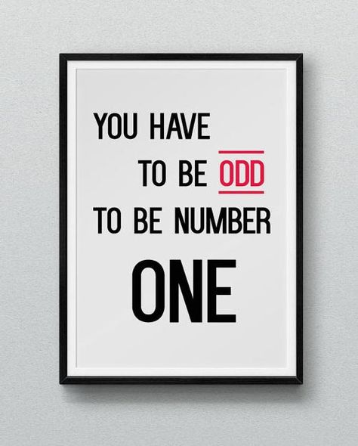**Food and Drink –** You may eat and drink **healthy, quiet food** in my class.

Should you choose to bring a Slurpee to class, you bring me one as well, or I toss yours. Not healthy. (This includes Iced coffee or Iced Cappuccino)

NO: Chips, Cookies, Carbonated beverages…

*If I find food on the floor after your class, food privileges will be lost for the entire class.

**Contact Information:**

**Teacher:** Miss Paige Gibbon

**e-mail:** paige.gibbon@pallisersd.ab.ca

**Remind:** @mathe10C

**Google Classroom:** code: 8dn8ba

Will be used to post assignments, keys, and digital lessons

**Grading Scheme**

Class Work 10% *Show me you can expand on what you learn*

Projects 20% *Show me you can apply and expand on what you learn*

Tests 40% *Show that you can combine and remember processes*

Final Exam 30% *Show you can remember what you have learned in this course*

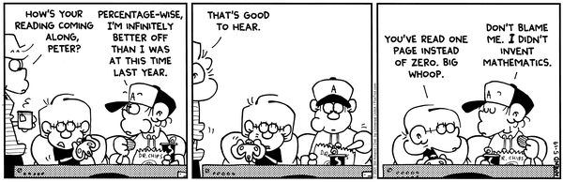

**Study**

**\*1 Rewrite may be earned\***

100 points and a test mark under 60%

5 – Bellwork Mark over 80%

3 – Puzzle completion

5 – Early Project Turn in (and earn over 60%)

10 – No more than 7 lates before review

10 – No more than 7 absences before review

Study strategies.

- Flash cards

- Note condensing

- Rework examples

- Teach a friend/sibling/parent…

- **Complete and review past assignments/tests and read comments**

Reduce anxiety

- Breathing Exercises

- Stretching

- Know the material

- Go for a run

- 5 senses

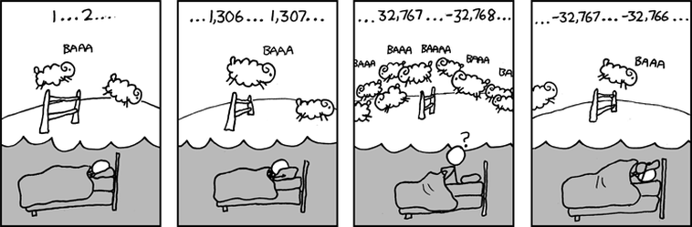

**Course Rationale**

“Mathematics is a broad-ranging field of study in which the properties and interactions of idealized objects are examined. Whereas mathematics began merely as a calculational tool for computation and tabulation of quantities, it has blossomed into an extremely rich and diverse set of tools, terminologies, and approaches which range from the purely abstract to the utilitarian.” (Wolfram MathWorld)

You have already learned the basics of math. You can find percent, measure accurately, use proportional reasoning, recognize patterns, and do arithmetic. These are the skills that you can use in your daily lives.

Going into math 10 C, you are now beginning to learn some of the more abstract math along with the utilitarian. This is a course designed to prepare you for post-secondary education in careers both calculus related (-1) and non-calculus related (-2). Be prepared to learn math that will have no practical day to day application, but will introduce skills that relate to the study of computer science, biology, engineering, accounting, psychology, geomatics, physics, astronomy, hydrology, and so much more. Many skills by themselves may seem pointless, but everything we study this year will lead up to further studies not only next year, but into University.

See <https://www.math.uci.edu/math-majors/math-career-resources> math related jobs, their descriptions, and potential salaries.

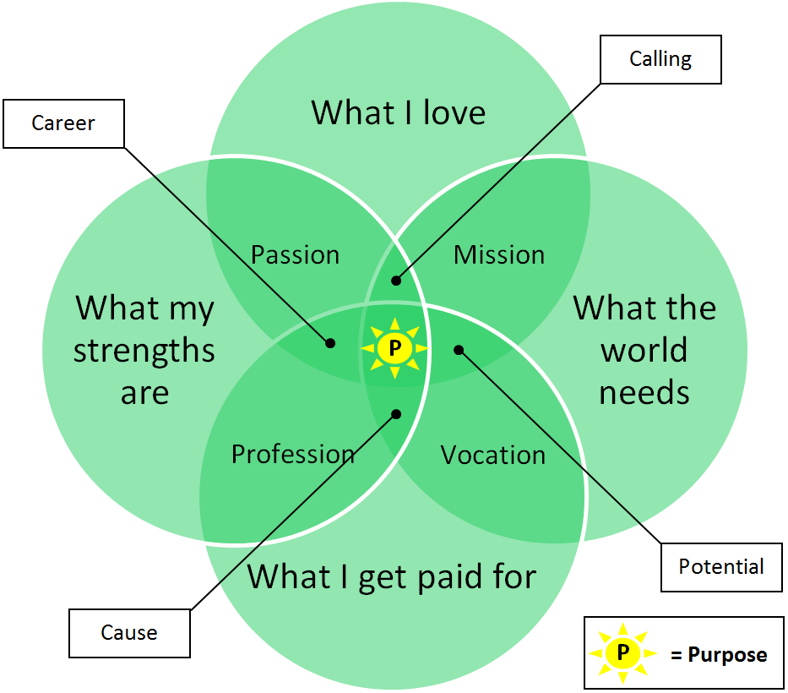

**Outcome Checklist and Timeline: 10 C**

*\*All timelines are tentative due to possible class disruptions and need for reviewing past concepts.*

*\*\*Anything written in italics after this point is optional and will depend on the pace of the class*

Rational vs. Irrational Numbers (10 classes)

______I can identify the prime factors of a number ……………………………………... Q1

______I can explain why 0 and 1 have no prime factors…………………………………. Q2

______I can calculate the GCF and LCM of a set of numbers……………………………. Q3

______I can explain how to calculate the GCF and LCM………………………………… Q4

______I can use GCF, LCM, and prime factors to solve problems……………………….. Q5

______I can determine if a number is a perfect square, perfect cube or neither…………....Q6

______I can calculate the square root of a perfect square…………………………………..Q7

______I can calculate the cube root of a perfect cube…………………………………….. Q8

______I can explain the process used to calculate and approximate square and cube roots.Q9

______I can solve problems involving square roots and cube roots………………………..Q10

______I can sort numbers into rational and irrational and explain the difference………… Q11

______I can determine the approximate value of a given irrational number……………….Q12

______I can locate approximately where a irrational number will fit on a number line…...Q13

______I can express entire radicals as mixed radicals……………………………………...Q14

______I can express mixed radicals as entire radicals…………………………………….. Q15

______I can explain what the index of a radical is and how it is used……………………..Q16

______I understand how N, W, Z, Q and ~Q are related to R *and C…………………………Q17*

Exponents (6 classes)

______I can explain why $a≠0$ when $a^{-n}$…………………………………………………E1

______I can explain why $a^{\frac{1}{n}}=\sqrt[n]{a}, n>0$………………………………………………….E2

______I can convert radicals to rational exponents and vice versa…………………………E3

______I understand and can apply the exponent laws

______ Multiplication/Division……………………………………. E4

______ Exponents of Exponents…………………………………… E5 $a^{0}=1$______ ………………………………………………………E6

______ Negative Exponents……………………………………… E7

______ Fractional Exponents……………………………………… E8

______I can solve problems using exponents and radicals…………………………………E9

______I can find the mistakes in an exponent simplifications…………………………….. E10

______*I can work with and simplify scientific notation……………………………………… E11*

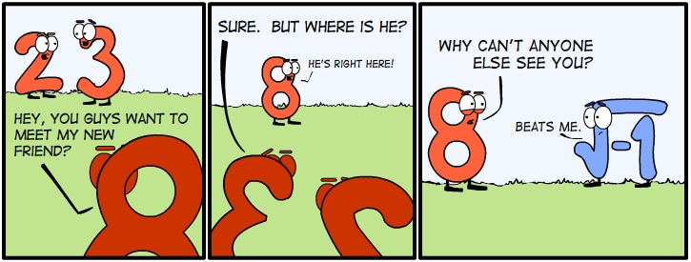­­­­

Polynomials (10 classes)

______I can recognize a polynomial in many forms……………………………………… P1

______I can model the multiplication of two binomials………………………………….. P2

______I can use the area model to represent the multiplication of binomials……………...P3

______I can explain how binomial multiplication is the same as two digit multiplication.. P4

______I can verify binomial multiplication using substitution…………………………….P5

______I can multiply binomials and simplify the result……………………………………P6

______I can explain strategies for multiplying binomials and polynomials………………. P7

______I can find errors in binomial multiplication…………………………………………P8

______*I can solve problems using the multiplication of binomials……………………………P9*

______I can determine the common factors of a polynomial and factor them out………... P10

______I can model trinomial factoring …………………………………………………… P11

______I can factor trinomials……………………………………………………………….P12

______I can factor and recognize a difference of squares………………………………… P13

______I can find mistakes in trinomial factoring………………………………………. P14

______I can verify factoring using *substitution* and multiplication……………………….. P15

______I can explain how multiplication and factoring are related………………………… P16

______I can explain strategies for factoring a trinomial……………………………………P17

______I can express a polynomial as a product of its factors………………………………P18

______*I can solve problems using the factoring of trinomials………………………………….P19*

Functions (7 classes)

______*I can understand and use the relationship between equations, tables of values, ordered pairs and graphs.(Review)………………………………………………………………. F1*

______I can apply what I know about data to decide if a function is discrete or continuous. F2

______I can identify independent and dependent variables in a context………………… F3

______I can describe a possible situation for a graph………………………………………F4

______I can sketch a possible graph for a situation……………………………………….. F5

______I can explain what it means to be a function……………………………………… F6

______I can explain why all functions are relations, but not all relations are functions….. F7

______*I can recognize and use piecewise functions…………………………………………… F8*

______*I can write an equation in two variables as a function……………………………….. F9*

______*I can write a function as an equation in two variables……………………………… F10*

______I can identify domain and range of functions and relations using number lines, set notation and interval notation…………………………………………………….. F11

______*I can use function notation to find corresponding range value (y-value) when given a value in the domain (x-value) and vice versa………………………………………….. F12*

______I can use the vertical line test to test if a relation is a function…………………… F13

______I can determine if a set of ordered pairs is a function…………………………….. F14

______I can sort graphs as functions or not functions…………………………………….. F15

______*I can write functions using function notation…………………………………………… F16*

______*I can use function notation to solve problems………………………………………… F17*

Linear Functions (15 classes)

______I understand what a linear relation is……………………………………………… L1

______I can determine if a situation represents a linear relation and explain my reasoning.L2

______I can determine if a table of values or set of ordered pairs represent a linear relation and explain my reasoning. ……………………………………………………………. L3

______I can graph a table of values and determine if it is a linear relation……………….. L4

______I can determine if an equation represents a linear relation and explain my reasoning…………………………………………………………………………… L5

______*I can use my graphing calculator to graph and access the table of values ………… L6*

______I can determine the x and y intercepts of a linear equation……………………….. L7

______I can determine the domain and range of a linear relation………………………… L8

______I can sketch and recognize linear relations with one, two or infinite intercepts….. L9

______I can identify a graph that corresponds to a given slope and y-intercept…………..L10

______I can identify the slope and y-intercept of a graph………………………………. L11

______I can solve problems using the x and y intercepts, slope, domain and range of a linear equation…………………………………………………………………………… L12

______*I can use my graphing calculator to calculate x and y intercepts…………………… L13*

______I can determine slope …………………………………………………………….. L14

______I can classify slopes as negative or positive………………………………………. L15

______I can explain the meaning of vertical and horizontal slopes………………………. L16

______I can explain why slope can be found using any two points on a line…………… L17

______I can use and recognize slope as a rate of change……………………………….. L18

______I can draw a line given a point on a line and its slope…………………………….. L19

______Determine other points on a line (may be partially specified or not) given the slope and one point on the line……………………………………………………………….. L20

______I can recognize when two lines are parallel or perpendicular……………………… L21

______I can identify equivalent linear relations from in a set of linear relations………… L22

______I can solve problems using slope………………………………………………….. L23

______I can recognize a linear equation in general, slope-intercept and slope-point form.. L24

______I can rewrite a linear equation in general and slope-intercept form……………… L25

______I can graph equations from slope-intercept form………………………………….. L26

______I can graph equations from slope-point form………………………………………. L27

______I can graph equations from general form………………………………………… L28

______I can explain my strategy for graphing equations in each form……………………. L29

______I can match linear relations to their graphs…………………………………………L30

______I can create the equation of a linear relation slope-intercept and/or slope-point form from it’s graph …

______ When given slope and y-intercept………………………… L31

______ When given slope and a point……………………………… L32

______ When given two point on the line…………………………. L33

______ When given a point on the line and equation parallel or perpendicular to the line……………………………………. L34

______I can create the equation of a line generated from a context……………………… L35

______*I can create the equation of a line of best fit……………………………………………. L36*

______*I can use a regression on my calculator to find the line of best fit………………….. L37*

______I can solve problems using the equation generated from linear data……………… L38

______I can use function notation to represent linear relations…………………………… L39

______I can use function notation to solve for needed domain(x) and range(y) values in linear functions…………………………………………………………………………… L40

______I can graph a linear function expressed in function notation………………………. L41

______I can match various representations of linear relations (table of values, equations, ordered pairs, graphs…) …………………………………………………………………… L42

Systems of Linear Equations (6 classes)

______I can model situations using systems of linear equations…………………………. S1

______I can relate a system of linear equations to the context of a problem………………S2

______I can graphically determine the solution to a system of equations with and without my calculator…………………………………………………………………………… S3

______I can explain the meaning of a point of intersection in a system of equations……. S4

______I can algebraically determine the solution to a system of linear equations………. S5

______I can explain why a system may have one, none or infinite solutions……………... S6

______I can explain a strategy to solve a system of linear equations and why it works….. S7

______I can solve problems involving systems of linear equations and relate the solution to the question…………………………………………………………………………….. S8

______I can find errors in a solution to a system of equations……………………………..S9

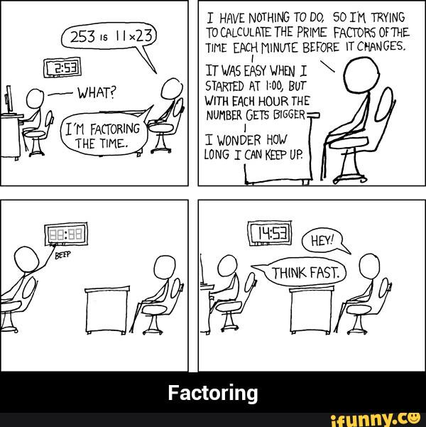

Trigonometry, Surface Area and Volume (10 classes)

______I can relate the primary trig ratios to similar right triangles……………………….. T1

______I can identify the hypotenuse of right triangles……………………………………. T2

______I can identify the opposite adjacent and hypotenuse from any acute angle on a right triangle……………………………………………………………………………. T3

______I can solve right triangles using the sine, cosine and tangent ratios, *Pythagorean theorem, and the sum of angles in a triangle……………………………………………………… T4*

______I can solve problems involving more than one right triangle……………………… T5

______*I can use a clinometer to measure inclination and declination……………………… T6*

______I can solve problems that involve direct and indirect measurement………………. T7

______I can sketch diagrams of 3D shapes to help me solve surface are and volume problems……………………………………………………………………………. T8

______I can determine the surface area and volume of …

______ Right comes……………………………………………… T9

______ Right cylinder……………………………………………… T10

______ Right prism……………………………………………….. T11

______ Right pyramid…………………………………………….. T12

______ Sphere…………………………………………………….. T13

______I can determine a missing dimension when given volume or surface area and the remaining dimensions……………………………………………………………… T14

______I can solve problems involving surface are and volume of a composite 3D object.. T15

______I can describe the relationship between the volumes of right cones and cylinders, and right pyramids and right prisms with the same height…………………………….. T16

______I can use the Pythagorean theorem to help solve trig, SA and Volume problems…. T17

Measurement (6 classes)

______I can provide and recognize referents for various imperial and SI linear measures.. M1

______I can compare imperial and SI units using referents……………………………… M2

______I can estimate a linear measure using referents…………………………………… M3

______I can justify my choice of linear measures for a particular measurement…………. M4

______I can solve problems that involve measurement with rulers, calipers, tape-measures, dressmakers tape, trundle wheels………………………………………………….. M5

______I can describe a strategy to calculate the linear measure of an irregular object……. M6

______I can use and explain how proportional reasoning can be used to convert between units………………………………………………………………………………… M7

______I can use and explain how unit analysis can be used to convert between units……. M8

______I can solve problems that involve the conversion of units………………………….M9

______I can justify the reasonableness of a solution to a conversion problem…………… M10

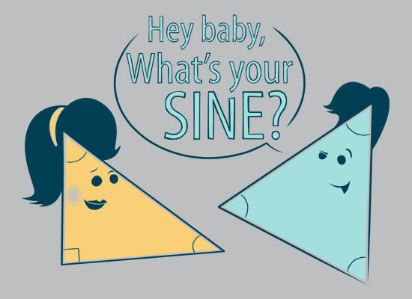**Final Review & Final Exam (~ a week of January/June)**