**Syllabus**

**Math 20-2**

**Miss Gibbon**

**Classroom Expectations**

**Be Open-minded** *~ If you see the worst in any situation or idea without first considering its merits, you only impede your own growth.*

**Be positive** ~ *Attitude is everything. Salt, like math, may not be so good on its own, but it can definitely make everything else that little bit more flavourful.*

**Be respectful** ~ *Others have the right to a quality education, same as you. Don't mess with that.*

**WORK IS EXPECTED TO BE NEAT.** (Use pencil and eraser or buy erasable pens)

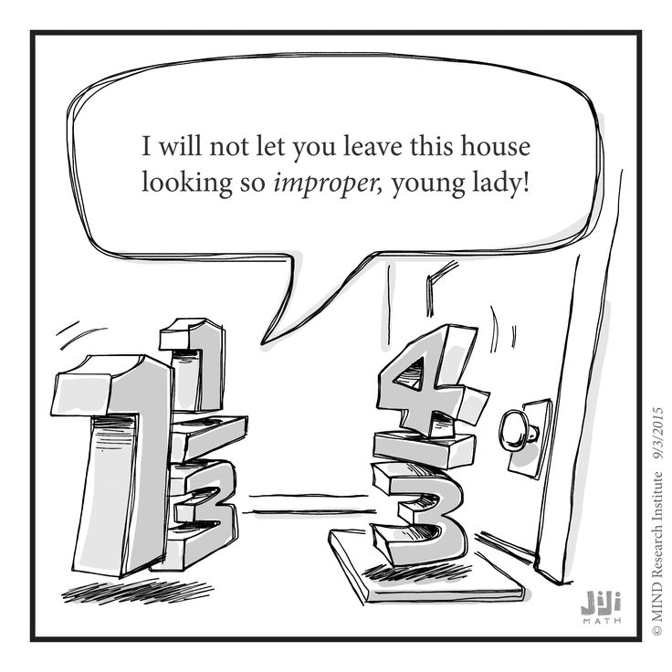

**Materials Required**

Binder

loose-leaf

graphing paper

Pencils and Erasers

Pens/Highlighters

**GRAPHING CALCULATOR**

**Lockdown/Fire drill Discussion**

**Classroom Routines**

**Late** – Sign in when you arrive. Send me a Remind with the reason for your late or you will remain absent.

Format: Late – A bear was standing on my keys. (3:05)

**Bathroom/Drink** – Sign out and sign in to the binder by the door. I need to know where you are AT ALL TIMES. Only one student may be out of the room at a time. When you leave you will close the binder so that others know someone is already out. Open it when you get back.

**Hand in** – There is a bin with your class name on it. **All** work is handed in here unless told otherwise.

**Can and Can’t Do’s**

**Technology** – Will only be used in my classroom at designated times. Parked at all other times in basket on my desk. This is a school wide policy.

Exceptions: When I give you permission (Access to keys, Bluetooth headphones during work time…

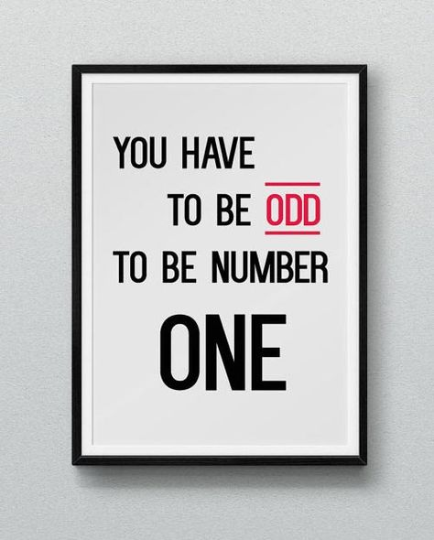**Food and Drink –** You may eat and drink **healthy, quiet food** in my class.

Should you choose to bring a Slurpee to class, you bring me one as well, or I toss yours. Not healthy. (This includes Iced coffee or Iced Cappuccino)

NO: Chips, Cookies, Carbonated beverages…

*If I find food on the floor after your class, food privileges will be lost for the entire class.

**Contact Information:**

**Teacher:** Miss Paige Gibbon

**e-mail:** paige.gibbon@pallisersd.ab.ca

**Remind:** @mathe202

**Google Classroom:** code: 067x4as

Will be used to post assignments, keys, and digital lessons

**Grading Scheme**

Class Work 5% *Show me you can expand on what you learn*

Projects 15% *Show me you can apply and expand on what you learn*

Research Project 10% *Show me that you can apply what we have learned to your life*

Tests 40% *Show that you can combine and remember processes*

Final Exam 30% *Show you can remember what you have learned in this course*

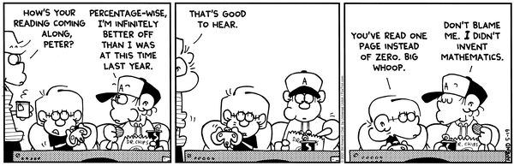

**Study**

**\*1 Rewrite may be earned\***

100 points and a test mark under 60%

5 – Bellwork Mark over 80%

3 – Puzzle completion

5 – Early Project Turn in (and earn over 60%)

10 – No more than 7 lates before review

10 – No more than 7 absences before review

Study strategies.

- Flash cards

- Note condensing

- Rework examples

- Teach a friend/sibling/parent…

- **Complete and review past assignments and read comments**

Reduce anxiety

- Breathing Exercises

- Stretching

- Know the material

- Go for a run

- 5 senses

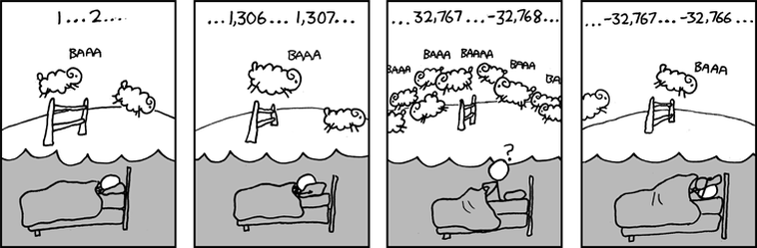

**Course Rationale**

“Mathematics is a broad-ranging field of study in which the properties and interactions of idealized objects are examined. Whereas mathematics began merely as a calculational tool for computation and tabulation of quantities, it has blossomed into an extremely rich and diverse set of tools, terminologies, and approaches which range from the purely abstract to the utilitarian.” (Wolfram MathWorld)

In 10 common you began to work in more abstract mathematics by using functions, studying polynomials and studying linear equations. In math 20-2 we expand on our studies of linear functions by applying them to the world around us, we use our knowledge of surface area and volume to study similar shapes and use scale factors accurately, we use our knowledge of trigonometry and angles to create proofs, solve problems and build a process for logic that relates to computer programming and law, we will study patterns related to quadratics and radicals to expand our knowledge of algebra, functions and formula use, and we will delve into the realm of statistics to see how numbers are used to make predictions in markets, warranties, and insurance.

Math 20-2 may not be as heavily algebraic as math 20-1, but the concepts presented in this course are geared toward mathematical learning at the university level. This is a good course to be in if you are leaning toward any field that requires university education, but is not a calculus based course. Some potential education would be marketing, business, nursing, physio, psychology, sociology, linguistics, nursing, marketing, business…

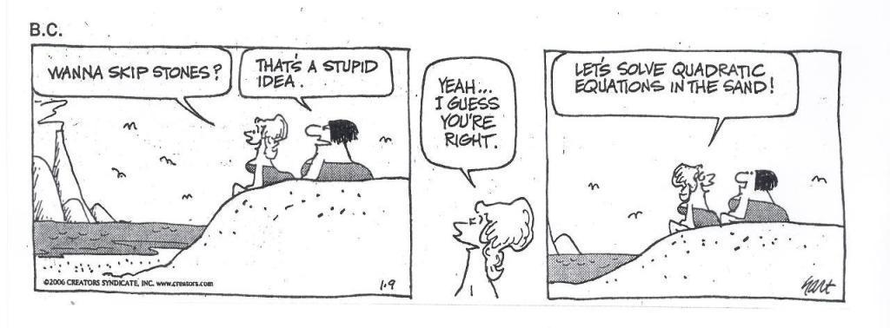

**Outcome Checklist and Timeline: 20-2**

*\*All timelines are tentative due to possible class disruptions and need for reviewing past concepts.*

Proportional Reasoning (13 classes)

­­­______I can interpret a rate in context…………………………………………………… P1

*______I can convert between units in rates……………………………………………….. P2*

______I can solve problems involving rates and unit rates……………………………… P3

______I can solve a rate problem that requires me to isolate a variable………………… P4

______I can calculate unit rates…………………………………………………………. P5

______I can compare unit rates………………………………………………………….. P6

______I can justify a decision made using unit rates…………………………………….. P7

______I can graph a rate………………………………………………………………….. P8

*______*I can calculate the slope of a graph…………………………………………….. *P9*

______I can explain the relationship between the slope of a graph and a rate…………… P10

______I can describe a context for a given rate…………………………………………. P11

______I can identify and explain factors that may affect a rate………………………….. P12

______I can explain how a scale diagram is used to model 2D and 2D shapes…………. P13

______I can determine the scale factor used to draw a representation…………………… P14

______I can use a scale factor to determine and unknown dimension ………………….. P15

______I can draw a scale diagram of a 2D shape using a given scale factor……………. P16

______I can solve problems that involve scale factor…………………………………….. P17

______I can determine the area of a 2D shape given the scale diagram………………….. P18

______I can determine the surface area of a 3D object given the scale diagram…………. P19

______I can determine the volume of a 3D object given the scale diagram…………….. P20

______I can explain how a linear scale factor is related to an area scale factor…………. P21

______I can explain how a linear scale factor is related to a volume scale factor………. P22

______I can solve spatial problems that require the manipulation of formulas…………… P23

______I can solve spatial problems using SA, Volume and scale factors……………….. P24

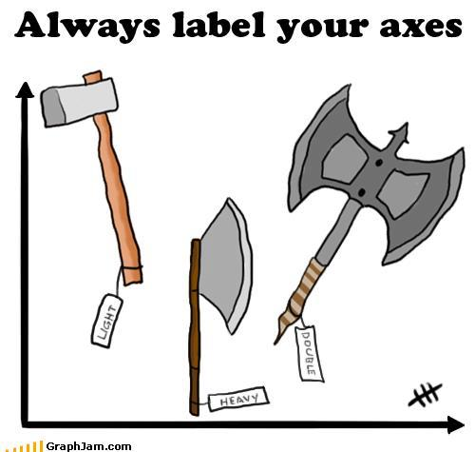

Puzzles and Logic (9 classes)

______I understand terminology like conjecture, inductive, deductive, counterexample… L1

______I can make conjectures by observing patterns and identifying properties………… L2

______I can justify the reasonableness of my conjecture………………………………… L3

______I can compare inductive and deductive reasoning using examples……………… L4

______I can provide and explain a counterexample to a conjecture……………………… L5

______I can use deductive reason to prove a conjecture…………………………………. L6

______I can build a deductive proof that includes my reasoning………………………… L7

______I can use let statements……………………………………………………………. L8

______I can algebraically portray number properties (odd, even, multiple…)……………. L9

______I can prove algebraic and number relationships such as…

______ Divisibility rules………………………………………………………….. L10

______ Number properties……………………………………………………….. L11

______ Number tricks…………………………………………………………….. L12

______I can determine if an argument is valid and justify the reasoning……………….. L13

______I can identify errors in a given proof……………………………………………… L14

______I can solve contextual problems that involve inductive or deductive reasoning… L15

______I can use the following strategies to win a puzzle or game

­______ Guess and check………………………………………………………….. L16

______ Look for a pattern………………………………………………………… L17

______ Make a list……………………………………………………………….. L18

______ Draw or model……………………………………………………………. L19

______ Eliminate possibilities……………………………………………………. L20

______ Simplify the problem……………………………………………………… L21

______ Work backward……………………………………………………………. L22

______ Create my own…………………………………………………………….. L23

______I can identify and correct errors in a solution to a puzzle………………………… L24

______I can identify and correct errors in a strategy for winning a game……………….. L25

______I can create a variation in a puzzle or a game and describe a strategy for solving/winning…………………………………………………………………… L26

Geometry & Trigonometry (12 classes)

______I can determine the measures of angles in a diagram that includes parallel lines, angles and triangles……………………………………………………………………….. G1

______I can justify the measures of angles in a diagram that includes parallel lines, angles and triangles……………………………………………………………………………. G2

______I can identify and correct errors in a solution involving angles and triangles…….. G3

______I can solve problems involving angles and triangles…………………………….. G4

______I can construct parallel lines given a compass, protractor, or *geometry program…. G5*

______I can explain how to construct parallel lines given a compass, protractor, or *geometry program……………………………………………………………………………………. G6*

______I can determine if lines are parallel given the measure of angles at the transversal…………………………………………………………………………. G7

______I can use inductive reasoning to explain the relationships between parallel lines and transversals……………………………………………………………………….. G8

______I can use deductive reasoning to prove properties of angles formed by transversals and parallel lines……………………………………………………………………….. G9

______I can use the sum of angles in a triangle to help build deductive geometric proofs……………………………………………………………………………… G10

______I can use inductive reasoning to relate the degrees in a polygon to the number of sides in the polygon……………………………………………………………………….. G11

______I can identify and correct errors in a deductive geometric proof………………… G12

______I can use inductive reasoning to verify that if lines are not parallel, transversal relationships do not apply…………………………………………………………. G13

______I can use deductive reasoning to prove that triangles are congruent…………….. G14

______I can draw diagrams to represent problems involving the sine and cosine laws… G15

______I can explain the steps in a proof of the sine or cosine law………………………. G16

______I can solve problems involving the sine law…………………………………….. G17

______I can solve problems involving the cosine law………………………………….. G18

______I can solve problems that involve more than one triangle……………………….. G19

Quadratics (15 classes)

______I can recognize quadratics in any form………………………………………….. Q1

______I can use vertex form to find the…

______ Vertex……………………………………………………………………… Q2

______ X intercepts………………………………………………………………… Q3

______ Y intercepts……………………………………………………………….. Q4

______ Domain and range…………………………………………………………. Q5

______ Axis of symmetry…………………………………………………………. Q6

______I can use technology to find the …

______ Vertex……………………………………………………………………… Q7

______ X intercepts………………………………………………………………… Q8

______ Y-intercepts……………………………………………………………….. Q9

______ Domain and range………………………………………………………… Q10

______ Axis of symmetry………………………………………………………… Q11

______I can use factored form to find the …

______ Vertex………………………………………………………………………. Q12

______ X-intercepts……………………………………………………………….. Q13

______ Y-intercepts……………………………………………………………….. Q14

______ Domain and range………………………………………………………….. Q15

______ Axis of symmetry…………………………………………………………. Q16

______I can determine the axis of symmetry when given the x-intercepts……………….. Q17

______I can determine the coordinates of the vertex given the equation and the axis of symmetry…………………………………………………………………………… Q18

______I can determine if the y-coordinate of the vertex is a max or min………………… Q19

______I can sketch the graph of a quadratic function using its characteristics………….. Q20

______I can sketch the graph of a quadratic function using technology…………………. Q21

______I can factor a quadratic…

______ Using GCF………………………………………………………………… Q22

______ Using multiply to the end, add to the middle……………………………… Q23

______ Using decomposition………………………………………………………. Q24

______I can factor to find the x-intercepts of a quadratic…………………………………. Q25

______I can use technology to find the x-intercepts of a quadratic……………………….. Q26

______I can explain why roots, zeros, x-intercepts, solutions are the same thing……….. Q27

______I can use substitution to verify the roots of a quadratic…………………………… Q28

______I can determine the roots of a quadratic using the quadratic formula……………… Q29

______I can use examples to explain why a quadratic may have 0, 1 or no solutions……. Q30

______I can create the equation of a quadratic using

______ the roots………………………………………………………………..… Q31

______ vertex form……………………………………………………………….. Q32

______I can model a situation with a quadratic equation………………………………… Q33

______I can solve a quadratic equation to solve a problem……………………………… Q34

Radicals (10 classes)

*Square roots only*

______I can recognize a radical expression………………………………………………. R1

______I can compare and order radical expressions with numerical radicands…………. R2

______I can express a mixed radical as an entire radical……………………………….. R3

______I can express an entire radical as a mixed radical…………………………………. R4

______I can add and subtract radical expressions……………………………………….. R5

______I can multiply radical expressions……………………..…………………………. R6

______I can divide radical expressions……………………………………………………. R7

______I can rationalize a monomial denominator……………………………………….. R8

*Square and cube roots, only one radical*

______I can determine the values for which a square root is defined…………………….. R9

______I can determine the values for which a cube root is defined………………………. R10

______*I can use my graphing calculator to help me determine the restrictions…………… R11*

______I can understand the difference between restrictions and NPV’s………………… R12

______I can algebraically calculate the roots of a radical equation……………………… R13

______*I can use my graphing calculator to verify the solution to a radical equation……. R14*

______I can explain how to algebraically calculate the roots of a radical equation……… R15

______I can explain why some roots are extraneous……………………………………… R16

______I can solve problems by modelling with a radical equation……………………… R17

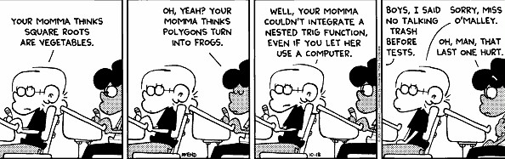

Statistics (11 classes)

______I can use examples to explain the meaning of standard deviation……………. S1

______I can use technology to calculate the standard deviation of a data set……………. S2

______I can explain and calculate the properties of a normal curve

______ Mean………………………………………………………………………..S3

______ Median…………………………………………………………………….. S4

______ Mode………………………………………………………………………. S5

______ Standard deviation ………………………………………………………………………………………… S6

______ Symmetry………………………………………………………………… S7

______ Area under the curve……………………………………………………… S8

______I can determine of a data set approximates a normal distribution…………………. S9

______I can compare the properties of two or more normal data sets…………………….. S10

______I can use standard deviation to make and justify decisions ………………………. S11

______I understand how consistency relates to standard deviation…………………….. S12

______I can solve problems that involve interpreting standard deviation……………….. S13

______I can calculate a z-score………………………………………………………….. S14

______I can use z-scores to compare normal distributions…………………………….. S15

______I can use z-scores to calculate percentage……………………………………….. S16

______I can use a percentage to find a z-score…………………………………………… S17

______I can solve contextual problems involving normal distributions and z-scores…… S18

______I can explain and calculate confidence levels……………………………………… S19

______I can explain and calculate margin of error……………………………………….. S20

______I can explain and calculate confidence intervals………………………………….. S21

______I can explain how confidence levels, margin of error and confidence intervals are effected by the size of the sample…………………………………………………………… S22

______I can make inferences about a population based on confidence intervals………… S23

______I can provide examples from media where confidence intervals are used to support a decision/position…………………………………………………………………. S24

______I can interpret and explain confidence intervals and margin of error using examples in media……………………………………………………………………………… S25

______I can support a position by analyzing statistical data presented in media………… S26

______I can draw a frequency polygon…………………………………………………….S27

______I can draw a histogram……………………………………………………………. S28

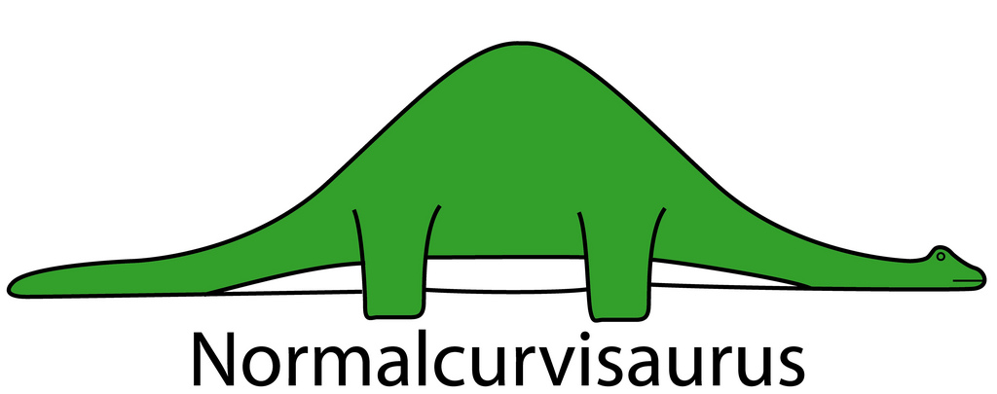______I can interpret histograms and frequency polygons as related to standard deviation…………………………………………………………………………. S29

Research Project (5 classes)

______I can collect primary or secondary data related to my topic………………….. RP1

______I can assess the accuracy, reliability and relevance of my data by…

______ Identifying bias and points of view………………………………………. RP2

______ Identifying and describing methods of data collection…………………… RP3

______ Determining if the data is relevant…………………………………………. R4

______ Determining if the data is consistent with data obtained from other sources on the same topic…………………………………………………………………. RP5

______If primary, I can interpret my data statistically…………………………………….. RP6

______I can identify controversial issues, if present, and present multiple sides of the issue with supporting data…………………………………………………………………… RP7

______I can organize and present my project, with or without technology………………. RP8

**Final Review & Final Exam (~ a week of January/June)**

