**Syllabus**

**Math 30-2**

**Miss Gibbon**

**Classroom Expectations**

**Be Open-minded** *~ If you see the worst in any situation or idea without first considering its merits, you only impede your own growth.*

**Be positive** ~ *Attitude is everything. Salt, like math, may not be so good on its own, but it can definitely make everything else that little bit more flavourful.*

**Be respectful** ~ *Others have the right to a quality education, same as you. Don't mess with that.*

**WORK IS EXPECTED TO BE NEAT.** (Use pencil and eraser or buy erasable pens)

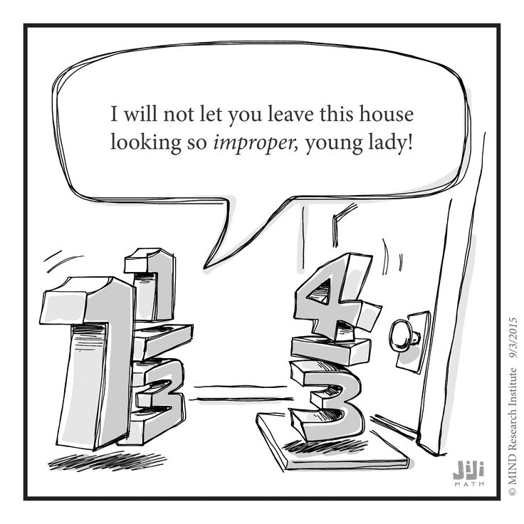

**Materials Required**

Binder

loose-leaf

graphing paper

Pencils and Erasers

Pens/Highlighters

**GRAPHING CALCULATOR**

**Lockdown/Fire drill Discussion**

**Classroom Routines**

**Late** – Sign in when you arrive. Send me a Remind with the reason for your late or you will remain absent.

Format: Late – A bear was standing on my keys. (3:05)

**Bathroom/Drink** – Sign out and sign in to the binder by the door. I need to know where you are AT ALL TIMES. Only one student may be out of the room at a time. When you leave you will close the binder so that others know someone is already out. Open it when you get back.

**Hand in** – There is a bin with your class name on it. **All** work is handed in here unless told otherwise.

**Can and Can’t Do’s**

**Technology** – Will only be used in my classroom at designated times. Parked at all other times in basket on my desk. This is a school wide policy.

Exceptions: When I give you permission (Access to keys, Bluetooth headphones during work time…

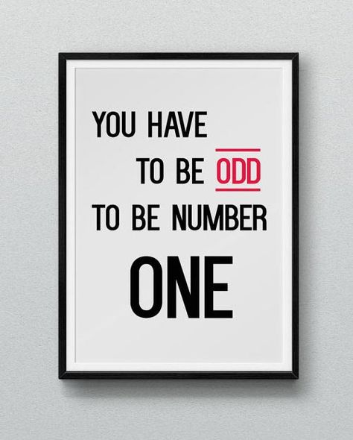**Food and Drink –** You may eat and drink **healthy, quiet food** in my class.

Should you choose to bring a Slurpee to class, you bring me one as well, or I toss yours. Not healthy. (This includes Iced coffee or Iced Cappuccino)

NO: Chips, Cookies, Carbonated beverages…

*If I find food on the floor after your class, food privileges will be lost for the entire class.

**Contact Information:**

**Teacher:** Miss Paige Gibbon

**e-mail:** paige.gibbon@pallisersd.ab.ca

**Remind:** @mathe302

**Google Classroom:** code: u4wc8ib

Will be used to post assignments, keys, and digital lessons

**Grading Scheme**

Class Work 10% *Show me you can expand on what you learn*

Projects 20% *Show me you can apply and expand on what you learn*

Research Project 10% *Show me that you can apply what we have learned to your life*

Tests 60% *Show that you can combine and remember processes*

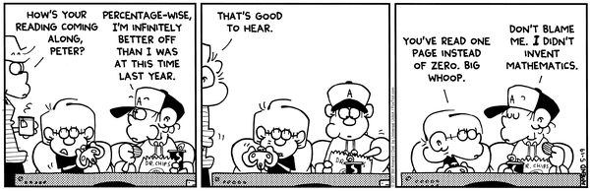

**Study**

**\*1 Rewrite may be earned\***

100 points and a test mark under 60%

5 – Bellwork Mark over 80%

3 – Puzzle completion

5 – Early Project Turn in (and earn over 60%)

10 – No more than 7 lates before review

10 – No more than 7 absences before review

Study strategies.

- Flash cards

- Note condensing

- Rework examples

- Teach a friend/sibling/parent…

- **Complete and review past assignments and read comments**

Reduce anxiety

- Breathing Exercises

- Stretching

- Know the material

- Go for a run

- 5 senses

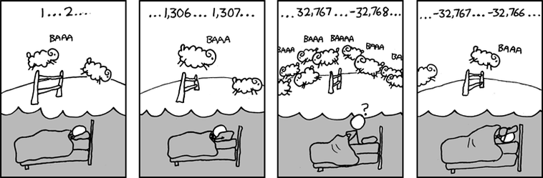

**Course Rationale**

“Mathematics is a broad-ranging field of study in which the properties and interactions of idealized objects are examined. Whereas mathematics began merely as a calculational tool for computation and tabulation of quantities, it has blossomed into an extremely rich and diverse set of tools, terminologies, and approaches which range from the purely abstract to the utilitarian.” (Wolfram MathWorld)

I am more than aware of how much the majority of students hate math, and I commend you on taking this course. To me that indicates that, as much as you may dislike my subject, you have come to the realization that you may need either the math, or the skills you will develop while learning math. MATH IS EVERYWHERE and I hope only to make you more aware of that, and give you some mathematical skills that will help you in your future professions.

I have learned to see the beauty in math. It is a constant that can be relied upon. There is always a correct answer, even when it can be hard to find or define. Math is used to define the laws and patterns in the world around us, and though you may choose to never use it, it will be around you nonetheless.

This year we will study a variety of patterns ranging from exponential, and polynomial to logarithmic and sinusoidal. We will use these patterns to create equations, establish trends, interpolate data and solve problems. We will also study rational equations to better enable us to solve problems relating to rates and delve into the study of set theory and probability to help us better understand counting methods and data sets. You will use notation, terminology, and equations that you may never see again, but by understanding these patterns now you will be better equipped to adapt to and learn any patterns that may be present in your future studies.

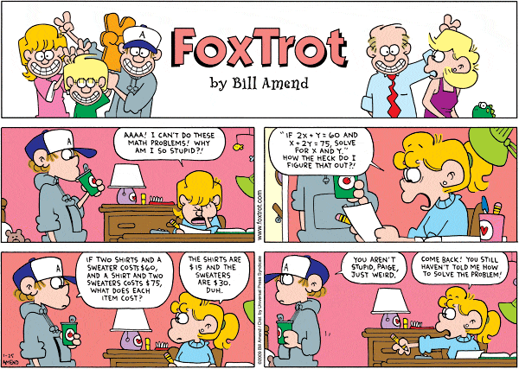

**Math around us**

In programming, mathematics not only defines what each key you press will do, but defines the motions and patterns you see on your screen. Math is in every letter, every curve, every line and every shot of that FPS weapon or RPG spell.

In physics, mathematics defines the laws of motion itself: gravity, projectiles, conservation of energy. Mathematics is what builds the equations on that formula sheet. Without math in physics we would know that the apple fell on Newton, but nobody could have defined the speed at which it conked him in the noggin.

You biology buffs, are you aware of how proportional our bodies are? Did you ever think about the volume of blood within you that your body needs in order to survive? Has your doctor ever measured your pulse or blood pressure to compare the rate of your heart to that which is statistically considered normal or safe? How do they even know when someone has high blood pressure without math! Your very DNA is made of numbers that are in a constant relation with calculable probabilities.

Perhaps social studies, archaeology or geography are more your style and I am happy to announce that there is math there too! Population increase, decrease, and density. Birth rates, death rates, statistical analysis of the voters in an age group that may be likely to vote for you to become Prime Minister. You see a graph of any sort and you just got Mathed.

You want to be a farmer? Seems pretty simple. Do you have enough money to buy seed, fertilizer, pesticides? How big is your farm? How much will you plant with wheat and how much will you fallow to maximize profit and reduce soil erosion? Even your cattle will thank you for correctly calculating the dose of vaccine needed to keep them ringworm and blackleg free.

Even my hairdresser was telling me about the mathematics that were required for her to complete her courses. Seriously, you do not want to use the wrong ratio of chemicals when mixing hair dye, or you will literally burn your clients and I promise they will not come back if you do that…

Ask me about your desired vocation sometime. I bet you will be surprised at how applicable math can be if you only learn it. I see new math around me every day and I revel in my understanding.

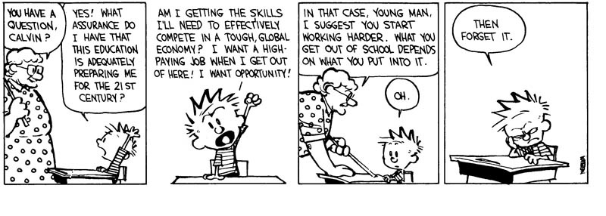

**Outcome Checklist and Timeline: 30-2**

*\*All timelines are tentative due to possible class disruptions and need for reviewing past concepts.*

Set Theory (10 classes)

* I can understand …
  + The empty set……………………………………………………………… S1
  + Disjoint sets………………………………………………………………. S2
  + Subsets……………………………………………………………………. S3
  + Universal sets……………………………………………………………. S4
  + Complement……………………………………………………………….. S5
* I can use graphic organizers to organize…
  + Collected data……………………………………………………………… S6
  + Number properties…………………………………………………………. S7
* I can explain how the following terms relate to Venn Diagram
  + And…………………………………………………………………………. S8
  + Or………………………………………………………………………… S9
  + Not………………………………………………………………………… S10
* I can use set notation to describe sets…………………………………………….. S11
* I can determine the elements in the compliment of two sets…………………….. S12
* I can determine the elements in the intersection of two sets……………………… S13
* I can determine the elements in the union of two sets……………………………. S14
* I can explain how set theory is used in search applications……………………… S15
* I can identify and correct errors in a solution to a problem that involves sets…….. S16
* I can solve problems that involve sets……………………………………………. S17
* I can use set notation to record my solutions……………………………………. S18
* I can solve problems that involve a variable in a Venn diagram

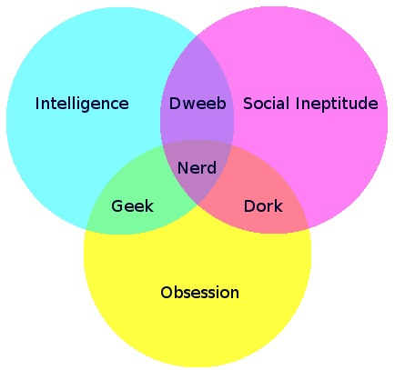

Probability (16 classes)

* I can provide examples of probability and odds in media, biology, sports, medicine, sociology, psychology, ……………………………………………………………. P1
* I can explain the difference between odd and probability………………………… P2
* I can calculate odds from probability……………………………………………… P3
* I can calculate probability from odds………………………………………………. P4
* I can determine the odds of an outcome………………………………………….. P5
* I can determine the probability of an outcome…………………………………….. P6
* I can solve problems involving odds and probability……………………………… P7
* I can explain how decisions may be based on probability, odds, or subjective judgement…………………………………………………………………………. P8
* I can accurately use/read probability notation…………………………………… P9
* I can classify events as mutually exclusive or non-mutually exclusive…………… P10
* I can explain why events are classified as mutually exclusive or non-mutually exclusive………………………………………………………………………….. P11
* I can determine if events are complementary……………………………………. P12
* I can explain why events are complementary……………………………………. P13
* I can use set notation to represent mutually exclusive and non-mutually exclusive events………………………………………………………………………………. P14
* I can use Venn Diagrams to represent mutually exclusive and non-mutually exclusive events……………………………………………………………………………… P15
* I can solve problems that involve the probability of mutually exclusive or non-mutually exclusive events……………………………………………………………………. P16
* I can solve problems that involve the probability of complementary events……… P17
* I can use probability notation to solve problems with mutually exclusive events… P18
* I can use probability notation to solve problems involving complimentary events..P19
* I can create a problem that involves mutually exclusive or non-mutually exclusive events…………………………………………………………………………….. P20
* I can compare dependent and independent event…………………………………. P21
* I can determine the probability of an event given the occurrence of a previous event………………………………………………………………………………. P22
* I can determine the probability of two independent events……………………… P23
* I can determine the probability of two dependent events…………………………. P24
* I can solve problems involving independent and dependent events……………….. P25
* I can use probability notation to solve problems involving independent/dependent events………………………………………………………………………………. P26
* I can create a problem that involves independent and dependent events………… P27
* I can solve counting problems using a graphic organizer…………………………. P28
* I can use graphic organizers to represent counting problems
  + Tree diagrams………………………………………………………………. P29
  + Charts………………………………………………………………………. P30
* I can explain the fundamental counting principle (addition and multiplication)….. P31
* I can identify assumptions made in solving counting problems…………………… P32
* I can solve counting problems……………………………………………………. P33
* I can represent the number of arrangements using factorial notation…………… P34
* I can determine the value of a factorial without technology……………………… P35
* I can determine the value of a factorial with technology…………………………. P36
* I can simplify numeric fractions involving factorials……………………………. P37
* I can simplify algebraic fractions that involve factorials………………………… P38
* I can solve equations that involve factorials……………………………………… P39
* I can determine the number of permutations of n elements taken r at a time……… P40
* I can determine the number of permutations of n elements taken n at a time where some elements are not distinct………………………………………………………….. P41
* I can use example to explain the effect on the total number of permutations when two or more elements are identical……………………………………………………….. P42
* I can use various strategies to determine permutations (key terms, diagrams…)…. P43
* I can solve contextual problems involving probability AND permutations………. P44
* I can explain the difference between permutations and combinations……………. P45
* I can determine the number of combinations of n elements taken r at a time…….. P46
* I can use various strategies to determine combinations (key terms, diagrams…)… P47
* I can solve problems that involve combinations AND probability……………….. P48

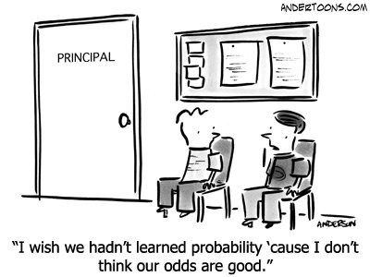

Rationals (12 classes)

* I can use what I know about equivalent fractions to compare rational expressions……………………………………………………………………… R1
* I can factor the numerator and denominator of rationals
  + Using GCF…………………………………………………………………. R2
  + Using multiply to the end, add to middle…………………………………. R3
  + Using difference of squares……………………………………………… R4
  + Using decomposition…………………………………………………….. R5
* I can simplify rationals……………………………………………………………... R6
* I can determine the NPV’s of a rational expression……………………………….. R7
* I can explain why the simplified version of a rational has the same NPV’s as the original……………………………………………………………………………. R8
* I can identify and correct errors in a simplification of a rational…………………. R9

*Focus on monomial/binomial numerator/denominator*

* I can use what I know about operations on fractions to relate to operations on rationals
  + Addition/subtraction………………………………………………………. R10
  + Multiplication/division…………………………………………………… R11
* I can add rationals with the same denominator…………………………………… R12
* I can subtract rationals with the same denominator………………………………. R13
* I can add rationals without a common denominator…………………………….. R14
* I can subtract rationals without a common denominator………………………….. R15
* I can multiply rationals…………………………………………………………… R16
* I can divide rationals……………………………………………………………… R17
* I can determine the NPV’s of a rational equation………………………………… R18
* I can algebraically determine the solution to a rational equation ……………….. R19
* I can explain and identify extraneous solutions to a rational equation……………. R20
* I can solve problems using rationals…
  + Velocity, distance, time…………………………………………………….. R21
  + Other rates………………………………………………………………… R22

Exponential and Logarithmic Equations (14 classes)

* I can convert from exponential to logarithmic…………………………………….. E1
* I can convert from logarithmic to exponential…………………………………… E2
* I can determine the value of a log without technology…………………………… E3
* I can determine the value of a log with technology………………………………. E4
* I can develop the laws of logs using numeric examples and the exponent laws.... E5
* I can simplify using log laws………………………………………………………. E6
* I can expand using log laws……………………………………………………… E7
* I can determine the solution of an exponential equation in which the bases are powers of one another…………………………………………………………………………. E8
* I can determine the solution of an exponential equation in which the bases are not powers of one another…………………………………………………………………….. E9
* I can use technology to verify the solution to an exponential equation………….. E10
* I can solve problems involving exponential equations
  + Finance………………………………………………………………… E11
  + Growth/decay………………………………………………………………. E12
* I can solve problems involving logarithmic scales
  + Richter scale……………………………………………………………….. E13
  + pH scale…………………………………………………………………… E14
  + Earthquake Intensity……………………………………………………….. E15
* I can describe the characteristics of an exponential function by analyzing its graph
  + Intercepts…………………………………………………………………. E16
  + Increasing/decreasing, domain and range…………………………………. E17
  + Asymptotes/NPV’s……………………………………………………….. E18
* I can describe the characteristics of a logarithmic function by analyzing its graph
  + Intercepts………………………………………………………………….. E19
  + Increasing/decreasing, domain and range………………………………….. E20
  + Asymptotes/NPV’s………………………………………………………… E21
* I can describe the characteristics of an exponential function by analyzing its equation
  + Intercepts………………………………………………………………….. E22
  + Increasing/decreasing, domain and range…………………………………. E23
  + Asymptotes/NPV’s……………………………………………………….. E24
* I can describe the characteristics of a logarithmic function by analyzing its equation
  + Intercepts………………………………………………………………… E25
  + Increasing/decreasing, domain and range………………………………….. E26
  + Asymptotes/NPV’s……………………………………………………….. E27
* I can match a graph to its equation………………………………………………… E28
* I can create a scatter plot to decide if logarithmic or exponential regression approximates the data…………………………………………………………………………….. E29
* I can create and interpret a logarithmic/exponential regression in my calculator… E30
* I can interpret the data presented in a logarithmic/exponential graph…………… E31
* I can use the graph of an exponential/logarithmic equation to solve problems
  + With a known x value…………………………………………………….. E32
  + With a known y value……………………………………………………… E33

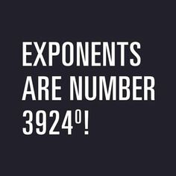

Polynomials (6 classes)

* I can describe the characteristics of a polynomial by analyzing its graph
  + Degree……………………………………………………………………… D1
  + Intercepts…………………………………………………………………… D2
  + End behavior………………………………………………………………. D3
  + Domain and range…………………………………………………………. D4
* I can describe the characteristics of a polynomial by analyzing its equation
  + Degree……………………………………………………………………… D5
  + Intercepts………………………………………………………………….. D6
  + End behavior………………………………………………………………. D7
  + Domain and range………………………………………………………… D8
* I can match equations to their graphs…………………………………………….. D9
* I can graph data to determine which polynomial regression best approximates it… D10
* I can create and interpret a polynomial regression in my calculator……………… D11
* I can interpret the data in the polynomial graph………………………………….. D12
* I can use the graph of the polynomial to solve problems
  + With known x values……………………………………………………… D13
  + With known y values…………………………………………………….. D14

Sinusoidal Functions (7 classes)

* *I can ensure my calculator is on the correct setting to graph a particular sinusoidal function……………………………………………………………………………………. A1*
* I can describe the characteristics of a sinusoidal function by analyzing its graph
  + Amplitude…………………………………………………………………. A2
  + Period……………………………………………………………………… A3
  + Midline (median)…………………………………………………………... A4
  + Intercepts………………………………………………………………….. A5
  + Domain and range…………………………………………………………. A6
  + *Sine vs Cosine……………………………….…………………………………… A7*
* I can describe the characteristics of a sinusoidal function by analyzing its equation
  + Amplitude…………………………………………………………………. A8
  + Period……………………………………………………………………… A9
  + Midline (median)………………………………………………………….. A10
  + Intercepts………………………………………………………………….. A11
  + Domain and range………………………………………………………… A12
  + *Sine vs cosine………………………………….………………………………….. A13*
* I can match equations to their graphs……………………………………………. A14
* I can use the characteristics of a sinusoidal function to create an equation……….. A15
* *I can convert between sine and cosine equations……………………………………… A16*
* I can create and interpret a sinusoidal regression in my calculator……………… A17
* I can interpret the data in the sinusoidal graph…………………………………… A18
* I can use the graph of the sinusoidal to solve problems
  + With known x values……………………………………………………… A19
  + With known y values……………………………………………………… A20

Logic (To be completed during review time ~2 weeks in June)

* I can determine, explain and verify a strategy to win a puzzle or game using…
  + Guess and check………………………………………………………….. L1
  + Look for a pattern …………………………………………………………. L2
  + Draw or model……………………………………………………………. L3
  + Eliminate possibilities……………………………………………………. L4
  + Simplify the problem……………………………………………………… L5
  + Work backwards………………………………………………………….. L6
  + My own approach………………………………………………………….. L7
* I can identify and correct errors in a solution to a puzzle/ or a strategy for winning a game……………………………………………………………………………… L8
* I can create a variation on a puzzle or game and describe a strategy for solving/winning……………………………………………………………………. L9

Research Project (5 classes)

* I can collect primary or secondary data related to my topic………………….. R1
* I can assess the accuracy, reliability and relevance of my data by…
  + Identifying bias and points of view………………………………………. R2
  + Identifying and describing methods of data collection…………………… R3
  + Determining if the data is relevant…………………………………………. R4
  + Determining if the data is consistent with data obtained from other sources on the same topic…………………………………………………………………. R5
* If primary, I can interpret my data statistically…………………………………….. R6
* I can identify controversial issues, if present, and present multiple sides of the issue with supporting data…………………………………………………………………… R7
* I can organize and present my project, with or without technology………………. R8

**Final Review & Final Exam (~ a week of January/June)**

